Audit: 21121 - Active Directory  
Work Step: E2.2 Event Monitoring  
  
DOCUMENT REQUEST  
Following the evidence you provided in Task15416, For the following SCOM event logs with change records generated on these days highlighted below,  
  
CHG0337321 - 01/14/2022  
CHG0336595 - 01/11/2022  
CHG0334646 - 01/01/2022  
CHG0333598 - 12/21/2021  
  
Please provide documentation evidencing the following:  
1. The AD infrastructure team performed root cause analysis. Also include record of change ticket.  
2. Identified issues were remediated

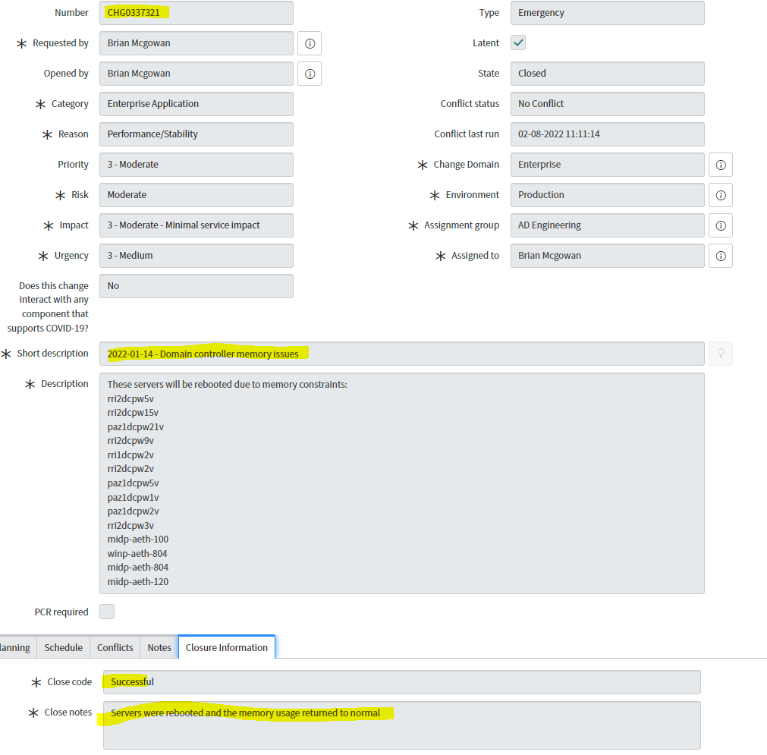

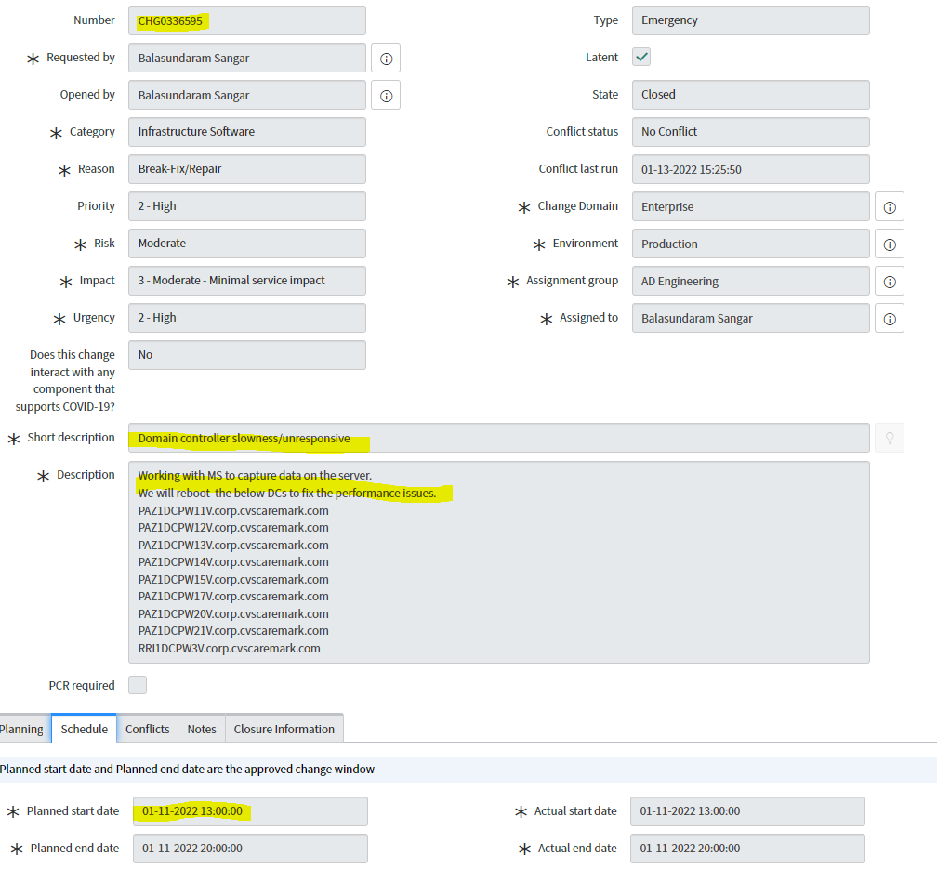

Pre-change documentation

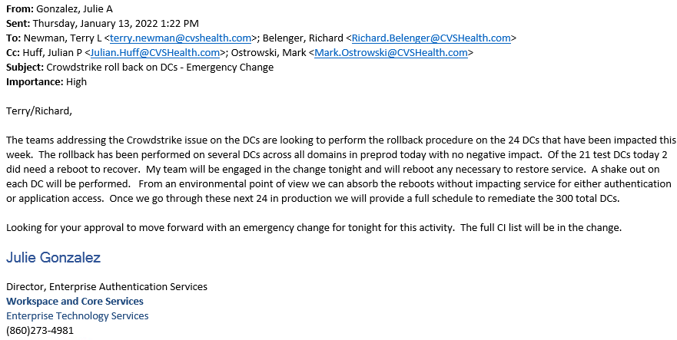

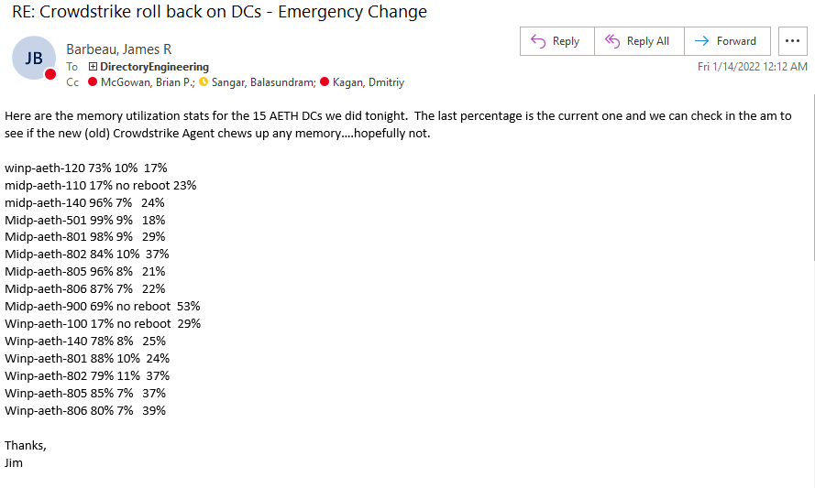

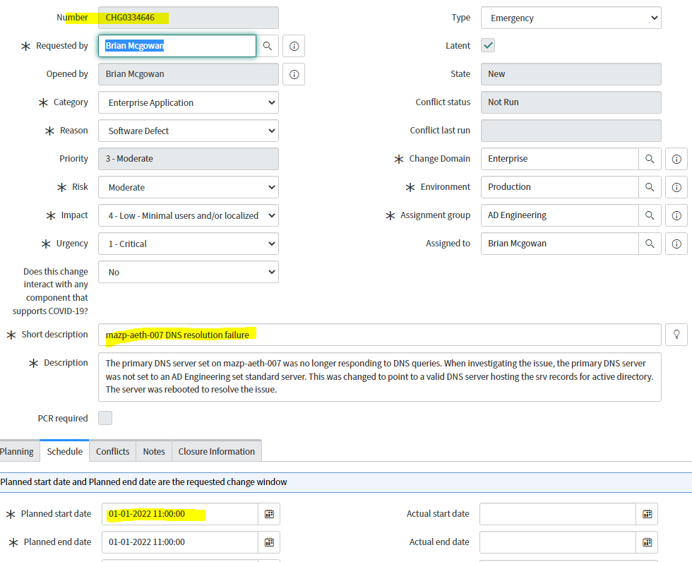

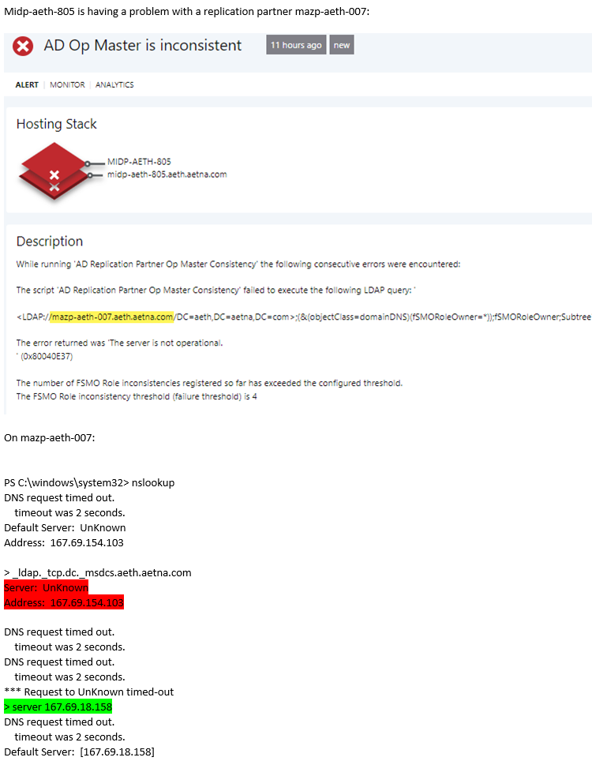

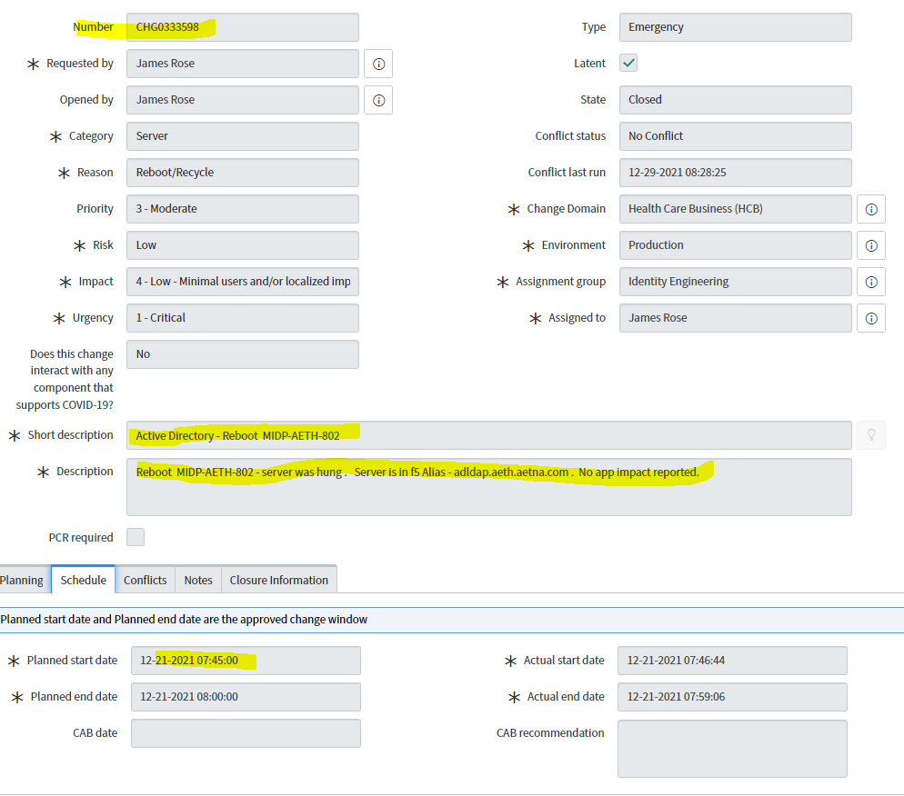

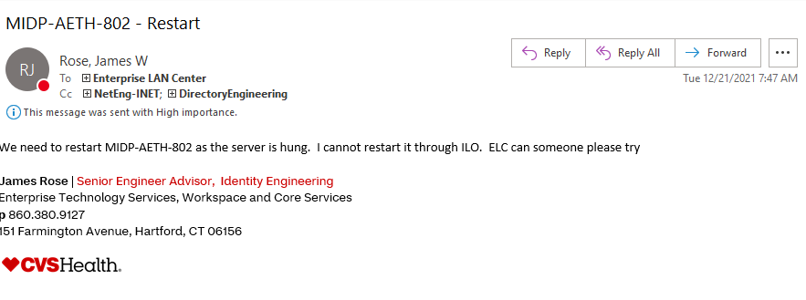

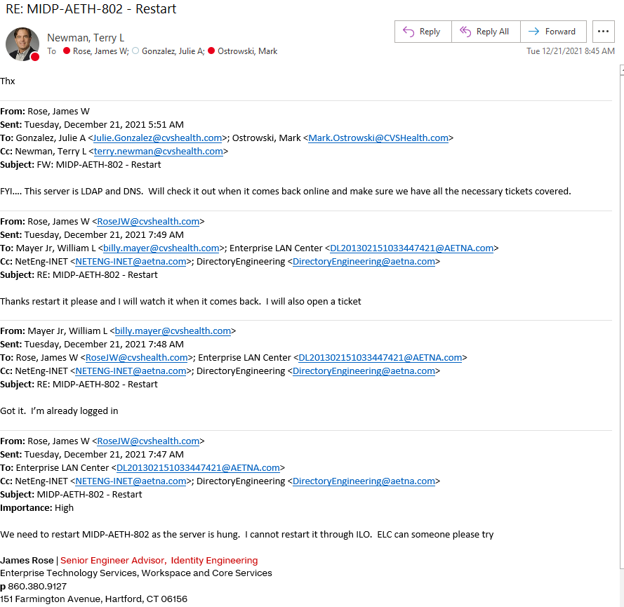32